Session 2 - Online behaviours
Resources
Resource Sheet 1 - Online and Offline behaviours | A copy for each pair or small group of students prepared by cutting into 14 cards
Rules for online behaviour | Flipchart for each group of 6 students. Pen/pencil for each student.
Resource Sheet 2 – Netiquette Charter | A copy for each student
Video clip- Can I be your Friend?  https://youtu.be/aDycZH0CA4I | Computer, projector and screen
PowerPoint Slide 3 | Computer, projector and screen
My evaluation sheet | Each student has a copy
My Acceptable User Policy | Each student has a copy

Intended learning outcomes: ‘I …’ statement(s)
I can describe online behaviours that can make people feel accepted and included
I know how to behave towards others as I would like others to behave towards me online
I understand that, if people show unacceptable behaviour online, there can be serious consequences. There are laws to deal with this.
Welcome
Welcome the students and ask what they liked best about the last session. Have they made any changes to their online behaviour or attitude to it since then?
Warm-up activity: 'Where are we?'
Purpose: to introduce the idea that different behaviours are appropriate in different contexts. To consider what it feels like to be excluded from a group because you don’t know how to behave.
Explain that you will ask for a volunteer to leave the room for a few minutes. The remaining students are going pretend they are in a particular context (e.g they are in a library or at a football match or in a kitchen) and show how they would behave in that context. They must not speak.
The student who left the room is going to try to work out what that context is by watching the group interact and then join in by acting in the same way once they understand the context and group behaviour.
Ask the students to choose a context and talk for a minute with a partner about how they will behave. Then invite the volunteer to join them.
Afterwards, discuss:
- how the volunteer felt when not understanding what the group were doing. What did it feel like when he/she understood and was able to join in?
- the importance of context in how we choose to behave or how our behaviour may be influenced.
Agree that when we are online we are in a particular context and we have to understand how to behave appropriately.
Review group aims
Remind students of the group aims. Which of them apply to working online? During this session we are going to think about the rules we want for online working..
Plan for today’s session
Explain that, today, we will work on these learning outcomes for each student in the group.
- I can describe online behaviours that can make people feel accepted and included
- I know how to behave towards others as I would like others to behave towards me online
- I understand that, if people show unacceptable behaviour online there can be serious consequences. There are laws to deal with this.
Ensure they understand the learning outcomes and remind them you will be asking them at the end of the session to think about whether they think they have been achieved.
Core Activity 1: Online and offline behaviours
Purpose: To consider how different behaviours might appear online
Ask students to work in pairs or small groups and give each group a set of cards from Resource Sheet 1. Ask them to try to match the cards to each other.
Discuss
- Which cards match each other?
- Are they true matches?
- Can they suggest other online behaviours and their offline equivalents?
Discuss the fact that;
- We behave differently online and offline
- People accept very different behavior online and offline
- We engage with people online who we do not know and are not familiar with
- We may share or engage more online with a stranger than we would in an offline situation
You could use the Video clip 'Can I be your friend?' which compares online and offline behaviour to illustrate these points.
Can I be your friend? https://youtu.be/aDycZH0CA4I
Need to clip video

Core Activity 2: Our rules for online behaviour
Purpose: To consider appropriate online behaviours, how students wish to be treated online and how they will treat others.
Online behaviour is often called ‘netiquette’ – etiquette for the internet
Ask what rules students would want for online behaviour. Ask for one or two examples e.g.
- Be kind – treat others as you wish to be treated.
- Be polite
- Take care of others online – stand up for them when necessary
- Be careful what you share, respect your own privacy and other peoples’
- Use language (word choices, capitals) and emojis carefully
- If you repost other's content, credit them
- Be aware of how you feel when you post – if you are angry/upset, then wait before you post
Give each student a pen, divide them into groups of about 6 and, on a flip chart sheet, ask everyone to write - at the same time - any rules they would want for online behaviour. Collect and discuss their ideas.
Core Activity 3 : Netiquette Charter
Purpose: To focus students’ ideas about appropriate online behaviour
Ask students to work in small groups to use Resource Sheet 2: Netiquette Charter to write their own list of 5 rules for online behaviour.
Share and discuss their ideas
Core Activity 4: PPT -The Law and online behaviour
Purpose: To ensure that students know that the law can be applied to online behavior and that behaving inappropriately can have serious consequences.
Explain that, if people show unacceptable behavior online, there can be serious consequences. They might be prosecuted. Students may know examples of this that have been in the news.
Show PowerPoint:Slide 3 The Law to explain that, for example, there are 7 laws in the UK that deal with cyber-bullying. ( See https://www.localsolicitors.com/criminal-guides/the-law-on-cyber-bullying for notes for Facilitators that explain the function of these laws).
Review and reflection on intended learning outcomes and group aims
Ask the students to indicate how well they feel they have achieved the session learning outcomes by using ‘thumbs up, thumbs level or thumbs down’. If students indicate that they haven’t achieved the learning outcome ask why and ensure that you plan the next sessions accordingly, or offer further support if possible.
Ask them to complete their evaluation sheet and personal Acceptable User Policy for Session 2
You could ask whether, thinking about what we have done in this session, they have any questions they would like to have answered in future sessions.

Session 2. Resource Sheet 1: Online and offline behaviours

Prepare by cutting this sheet into 14 cards

Online behaviour | Offline behaviour
Like | Smile
Poke | Show interest
Retweet | Copy what someone else said or tell a story someone else told you
Follow | Keep in touch
Selfie | Self portrait
Comment | Give feedback
Friend request | Invite someone to join your group

Session 2. Resource Sheet 2: Netiquette Charter
Netiquette Charter
Our 5 rules for online behaviour
1.
2.
3.
4.
5.

Additional Resources
UK-English slang (check for most current terms- these change over time!)
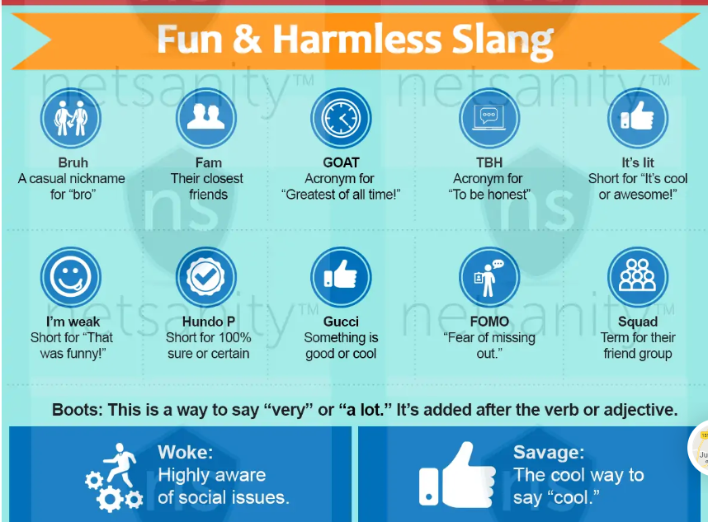

More UK-English slang
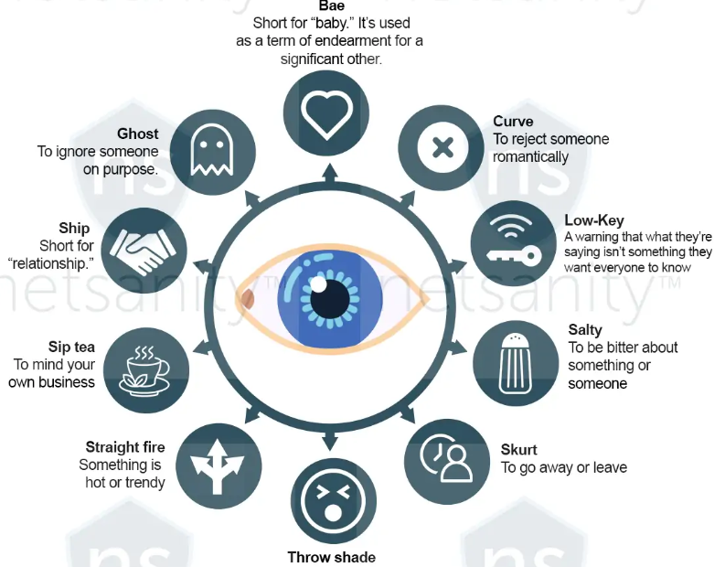
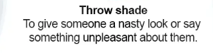
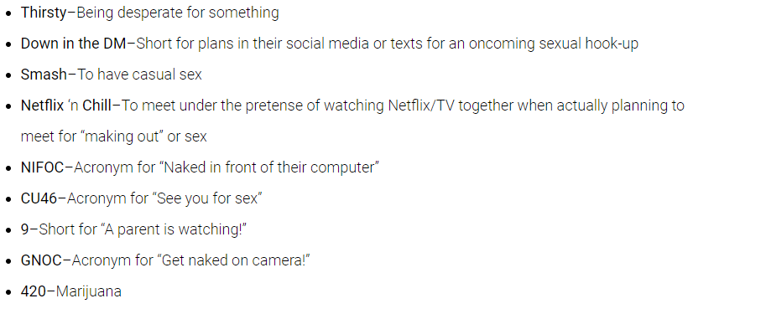
What do different emojis / abbreviations / acronyms that are commonly used online mean

Catfish - A catfish is someone who pretends to be someone else online – and it isn’t always easy to spot the difference between a catfish and a real person. We’ve put together some tips to help you spot a catfish as well as advice to help if you have been catfished by someone.
People catfish others online for a lot of different reasons. Sometimes it’s to:
- bully or humiliate someone
- try and get people to send nude/semi-nude images
- scam people into giving them money or personal details
- get a person into trouble
https://www.netsafe.org.nz/catfish/

