Session 4 – My child’s online presence
Resources
Resource sheet 1 | A copy for each small group
PowerPoint Slides 10-12 | Computer, projector and screen
Resource sheet 2 - Diary entries | A copy for each small group
Resource sheet 3 - Privacy scenarios | A copy for each group of parents/carers prepared by cutting into 5 cards
My evaluation sheet | Each parent/carer has a copy
My Acceptable User Policy | Each parent/carer has a copy

Intended learning outcomes: ‘I …’ statement(s)
I can help my child to develop and look after their online identity so that it shows their personal values, ambitions and beliefs
I can help my child to make the best choices to protect their data and online presence
I know how to help my child to be responsible and thoughtful about protecting the privacy of others online
Welcome
Welcome the parents/carers. Ask whether, since the last session they have done anything that to help their child’s digital resilience. How successful do they feel that it has been? What will they do next?
Review group aims:
Thinking of what we have discussed in our sessions so far, are there any changes they would want to make to them or their Netiquette Charter?
Plan for today’s session
Explain that, today, we will work on these learning outcomes for each parent/carer in the group.
- I can help my child to develop and look after their online identity so that it shows their personal values, ambitions and beliefs
- I can help my child to make the best choices to protect their data and online presence
- I know how to help my child to be responsible and thoughtful about protecting the privacy of others online
Ensure they understand what the learning outcomes mean and tell them you will be asking them at the end of the session to think about whether they think they have been achieved.
Warm-up activity: What can you guess from an online picture? Purpose: To make parents/carers aware of the necessity of being cautious about judging people by what they reveal online
Divide parents/carers into small groups and give each group a copy of Resource sheet 1. Ask them to look at the 4 profile pictures on the sheet and think about what they can see, what does it tell them?
For each picture ask:
What impression do you get from the picture?
Why did the person choose that image as their profile picture?
What 3 adjectives would you use to describe them? Write the adjectives under the picture.
Hand each group a copy of Resource sheet 2 – diary entries. Ask each group to guess which diary entry matches the profile picture of the person. Feedback from each group and take reasons for their answers.
Answers: could be A=1, B=4, C=2, D=3 but overall, there is no correct answer; any one of the diaries could be any of these people’s profiles. It is important not to judge others by how they portray themselves online. You are only seeing what that person wants you to see; it isn’t a true reflection of their everyday life.
Core Activity 1: Life Tree
Purpose: To help parents/carers think about what defines their identity and decide which aspects they will reveal online and how this can help them to help their child to craft their own online identity
Explain that we are going to think about how we create our own online identity and how they can support their children in creating theirs.
Ask parents/carers to think of themselves as a tree! What might they look like? A tall, willowy tree, a solid, strong oak or something else?
Show PPt Slide 11
Explain you are going to help them to imagine their personal tree. They will need to close their eyes and listen to your words and let their imagination roam free. Reassure participants they are safe and in a safe space. If they are not comfortable closing their eyes encourage them to put their head on their hands.
Say “Please close your eyes
- Imagine your roots are stretching down and anchoring you tightly into the warm, earthy soil
- You can feel the bright, warm sunlight on your trunk and you can feel a tingling moving up your legs as you begin to slowly grow taller up towards the light
- The sun continues to beat down on you warming you from your tallest branch down to your deepest root
- You can feel your branches stretching out and the buds are bulging ready to burst into blossom.
How does it feel like to burst into life like that?”
Show PPt Slide 12
Explain each section detail:
- Roots: where they came from – places, people, events that have been important in their past
- Trunk: the resources they have both within themselves (strengths, skills, qualities) and who else they can turn to for support
- Branches: what they want to achieve in their next few years.
Ask participants to draw their tree thinking about the 3 different sections and label them with their own roots (experience) trunk (resources and support) and branches (aspirations)
Encourage discussion of ideas and feelings as the trees take shape.
Then ask the group to work in pairs and talk through their tree drawings with each other. Decide in pairs which aspects they would share as part of their online identity.
Discuss how they will help their child to craft their online identity. Did this activity help them to think about this?
Stress the importance of thinking about safety and security when we do anything online. We will talk more about this.
Core Activity 2: What information can be gathered about us online?
Purpose: To start parents/carers thinking about the information about their children that is gathered online and how to help them to be cautious about what they reveal. This topic is covered more fully in Session 6.
Create a quick mindmap of information parents/carers think can be gathered about us online. e.g. our location or which advertisements we have clicked on
Add any information they haven’t thought of. (See https://www.globalsign.com/en/blog/what-data-is-collected-about-you-online)
Core Activity 3: Privacy scenarios
Purpose : to explore issues of privacy.
Use Resource sheet 3. Ask parents to discuss
- What they think their child should do in each of the situations described.
- What they think their child would actually do
You could divide the group into 5 smaller groups, each to work on a scenario card and then feedback their ideas and discuss with the whole group. Or you could focus on each card in turn as a whole group and discuss opinion.
Agree that it is important for their children always to be aware of issues of privacy online and act kindly and responsibly. How will they help them to do this?
Review and reflection on intended learning outcomes and group aims
Ask the parents/carers to indicate how well they feel they have achieved the session learning outcomes by using ‘thumbs up, thumbs level or thumbs down’. If parents/carers indicate that they haven’t achieved the learning outcome ask why and ensure that you plan the next sessions accordingly, or offer further support if possible.

Ask them to complete their evaluation sheet and personal Acceptable User Policy for Session 4

Ask each of them to say one important idea they will take away from today’s session.

Session4 . Resource Sheet 1: What can you guess from an online picture?
CROSSING THE LINE
FILM 4: TALKING HEADS

A

- Why did he choose this picture as his profile picture?
- What adjectives would you use to describe him?

B

- Why did she choose this picture as her profile picture?
- What adjectives would you use to describe her?

D

- Why did the boy with the ball choose this picture as his profile picture?
- What adjectives would you use to describe him?

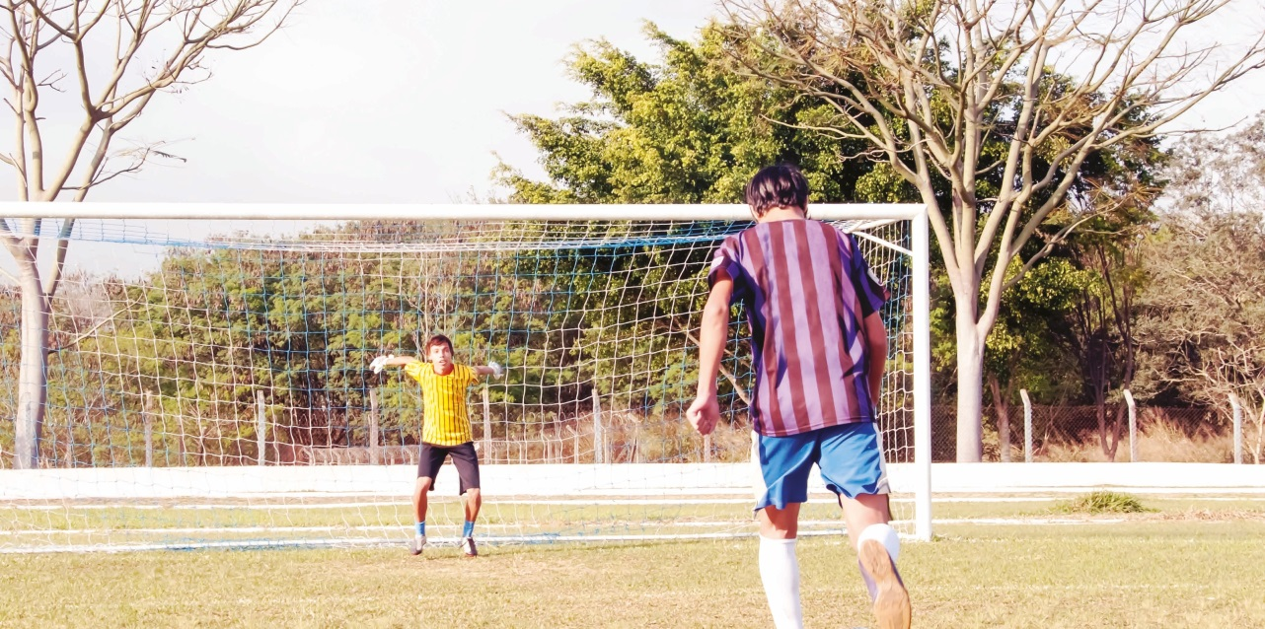
CROSSING THE LINE
FILM 4: TALKING HEADS

Session 4. Resource Sheet 2: Diary entries

Diary of Person 1. I had a really bad day today, nothing seemed to work out well. I missed the bus and forgot to take the jacket I had borrowed from my friend and I was really late getting to school. The whole day I just kept getting angry with myself for doing everything wrong. I just want to cry every time I look in the mirror. Sometimes I change my profile on social media so that I get some instant feedback from friends. They always know how to make me feel good about myself.

Diary of Person 2. Today was an excellent day! I did really well in an exam that I thought I had failed. I tried on some jeans that I thought didn’t fit me anymore and it seems that they still do! I changed the profile picture online to a time when I was really happy to reflect the mood I’m in now.

Diary of Person 3. Have nothing to report. I’m bored. I was online for about 5 hours today. My eyes started to go watery. I wonder what I was doing for those 5 hours…where does the time go? Everyone seems to be having a great time. I just changed my profile picture because I’m bored.

Diary of Person 4. I got new clothes today. I’ve been reading so many blogs recently about fashion online - they are great. Online shopping is also brilliant but, whenever I get the clothes, they never look the same on me as they do on the models. Anyway, my friend just asked me what I had bought so I put a new profile picture up to show me wearing my new top. I hope people don’t think I’m vain for doing that.

Session 4. Resource Sheet 3: Privacy scenarios
(Adapted from Safer Internet Day materials) Prepare by cutting into 5 separate cards
1. You’re signing up to the website of a new game. The form asks for the following details: Full name, email address, home address, telephone number.

What do you do?

A Give them all the details. Companies and organisations can always be trusted to look after their customer’s personal information.

B Report the game – personal information should be kept private and secure.

C Check the webpage for further details about why they need the information or ask an adult to help.

2. Your Mum has given you permission to borrow her phone to use your favourite app. Whilst you’re using the phone, a notification pops up showing your Mum has received a new message and it looks like it’s about you.

What do you do?

A Hand the phone back to your Mum – it’s her phone so the notification is for her, not you.

B Open the notification to read the message with your name in. It’s about you, so you should be allowed to read it.

C Exit the app and open your Mum’s messages. If there’s one message about you, there might be more and you have a right to know what they say.

3. You’re hanging out with several friends at your house, having fun and taking photos. You and your best friend love one of the photos and want to share it online, but another friend is less pleased with it.

What do you do?

A Share the photo anyway. There’s two votes for sharing it and only one for not.

B Don’t share the photo. Being a good friend means asking for consent and thinking about how your actions will impact other people.

C Try to convince your friend who doesn’t like it to change their mind. If you can get them to agree then it’s fine to post it.

4. You’ve been given permission to download a new game on a device shared by your family. After the download has completed a pop-up appears asking if the game can access the device’s camera, files and location.

What do you do?

A Say yes for all of them and get started playing the game.

B Select ‘no’ for now so you can play the game and see whether it works without access to the camera, files and location information.

C Select ‘no’ for now so you can check with the other people who use the device and decide whether the game needs to receive that information or not.

5. Last time your friend was at your house, you recorded a video of you singing together. You both agreed that you could post it online. When they next come round you record another singing video and you want to post it online again. What do you do?

A Check with them whether you’re allowed to post this video online too.

B Post the video online without checking. They said yes last time, so it’ll be the same for this one.

C It’s your video so it doesn’t matter what they think, you’ll post it anyway.

